November, 2016

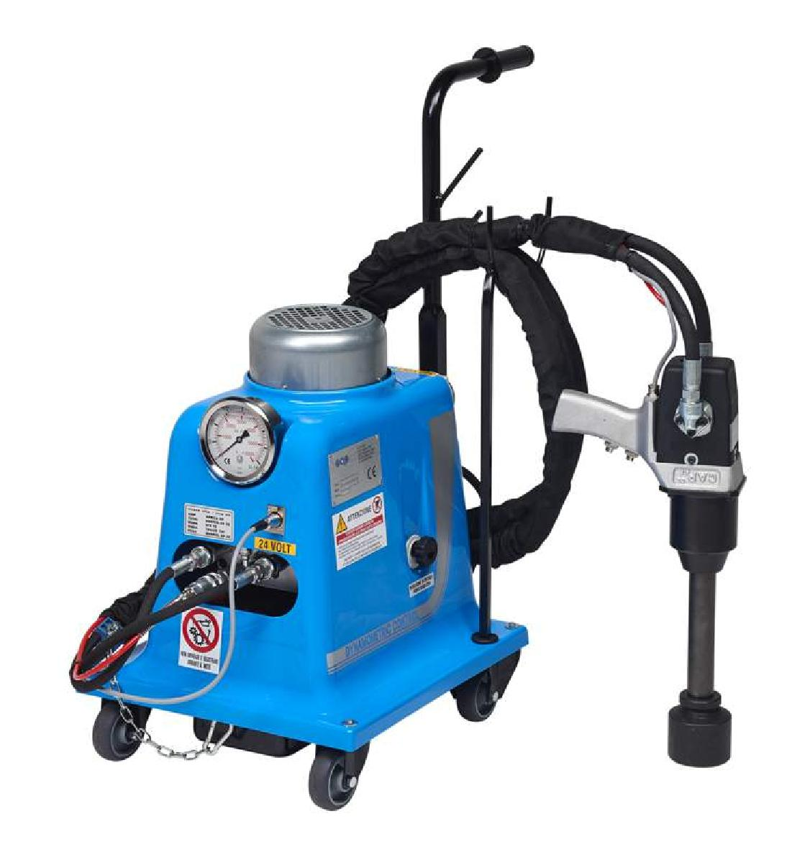
Product Portfolio

DYNAMOMETRIC CONTROL UNITS
DYNAMOMETRIC CONTROL UNIT

DYNAMOMETRIC CONTROL UNITS combine the speed and power of an impact wrench with the accuracy and repeatability of hydraulics in a reliable, durable and flexible bolting solution.

Cap’s range of 1” and 1,5” square drive Hydraulic Impact Wrenches provide exceptional working torque and outstanding power to weight ratio.

Whether you are in repair, maintenance or production CAP has a solution for you : just set “your” torque value on the movable Power Unit and remove or tighten the toughest industrial bolts as

many times as you want.
DYNAMOMETRIC CONTROL UNIT - Benefits

- Wide range of Hydraulicimpact Wrenches
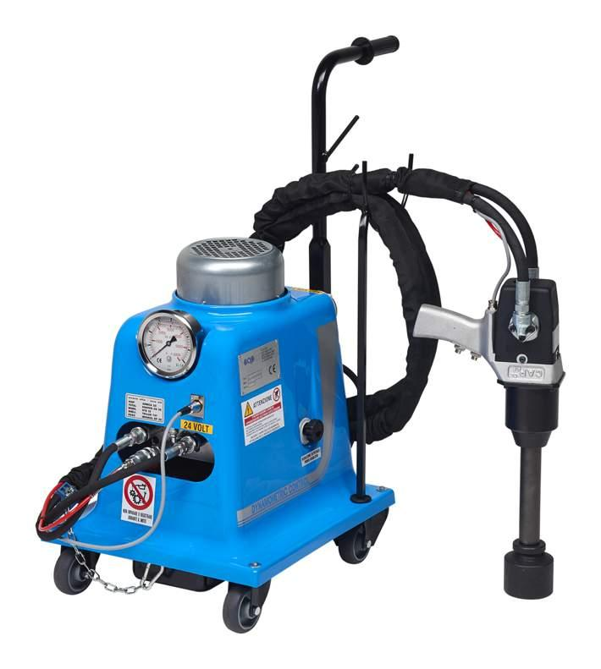
– 3/4“, 1’’ and 1.5’’
- Exceptionalworkingtorque range
– from 200Nm to 16000Nm

- Adjustable torque

- Torque consistency

- Torque precision
- Best industrial torque/weight ratio

- Durable, reliable and versatil

- Easy to use

- Clean and safe

- Low cost maintenance

- Mobile Power Unit

- Custom options
Hydraulic Impact Wrench Range
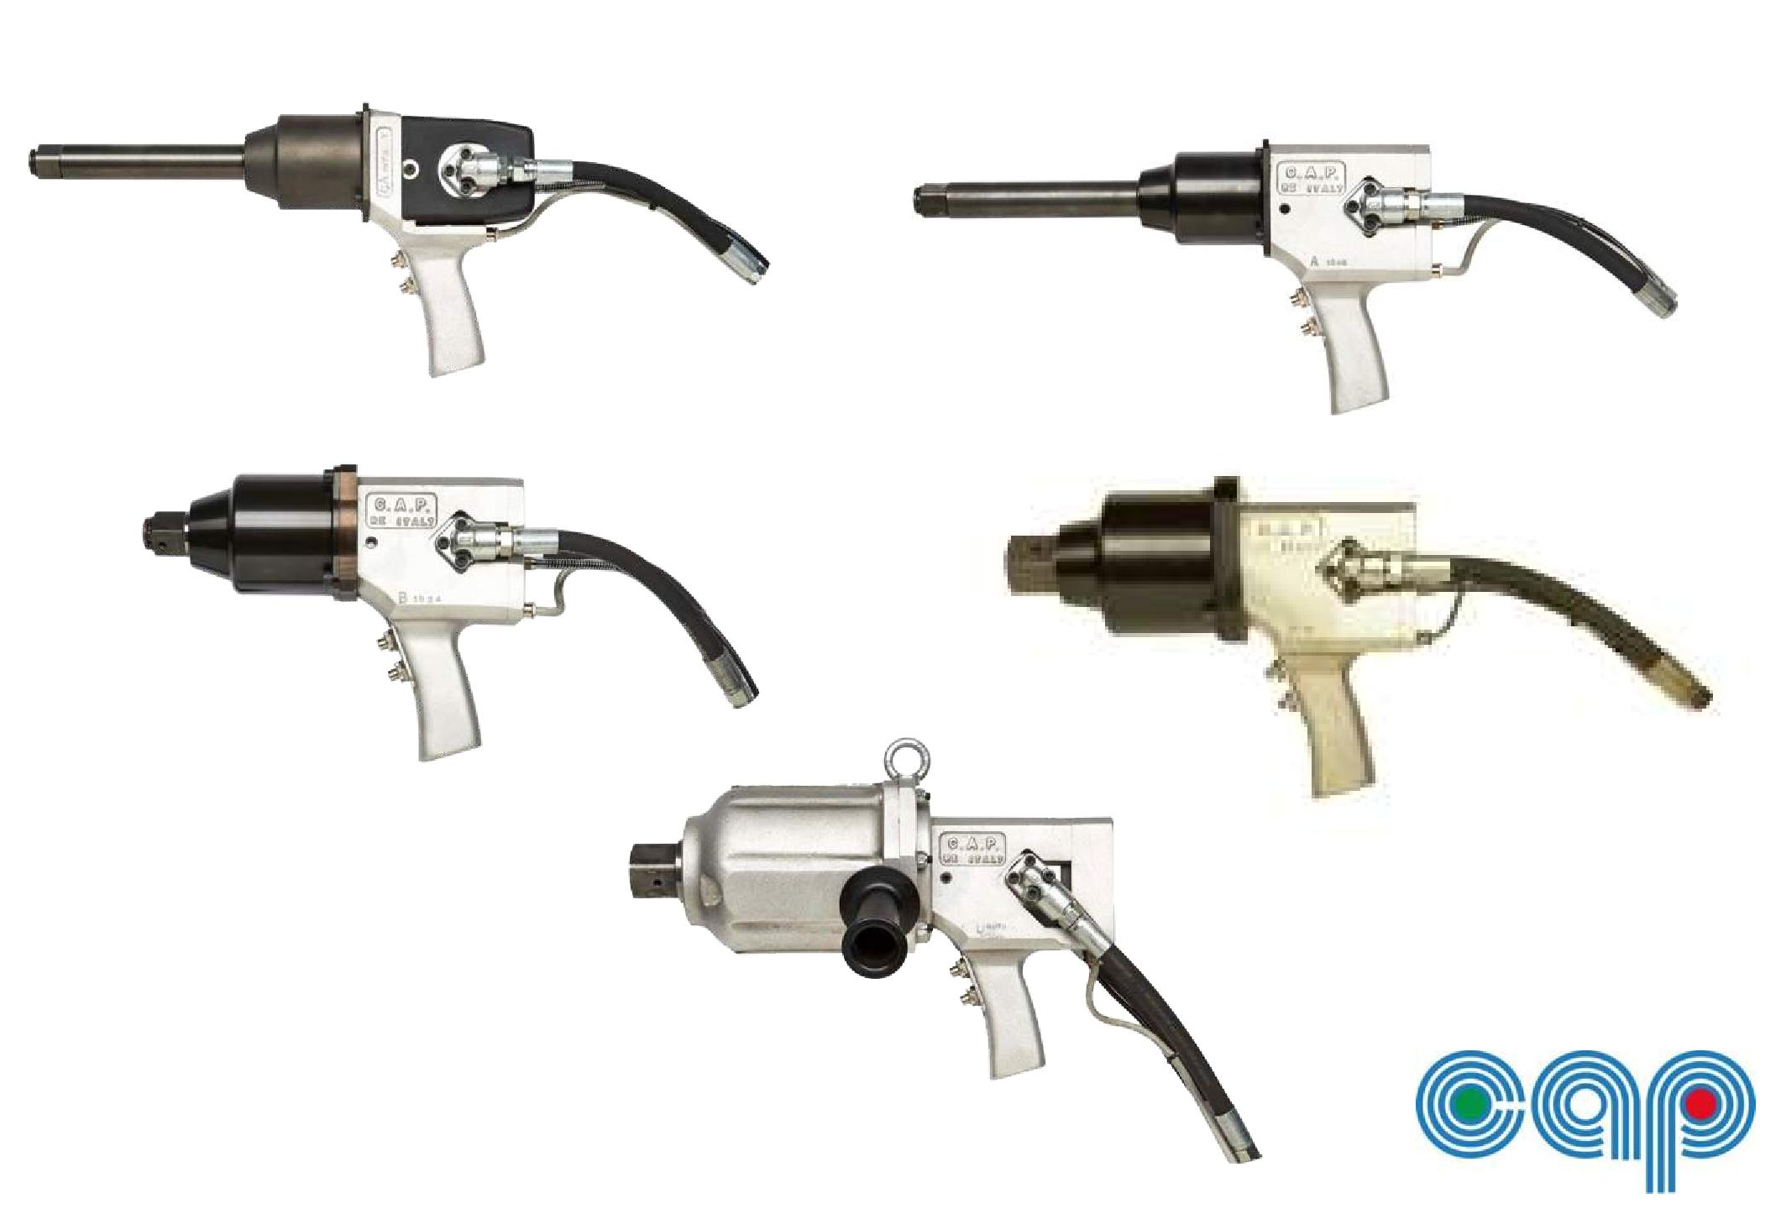
Hydraulic Impact Wrench Range

K200/K200L - Lightweight and compact 1” Impact Wrench designed for tire changing Applications and markets : tire changing, mechanics, general industrial maintenance

K350/K350L - Sturdy 1” Impact Wrench designed for vehicle service and industrial maintenance Applications and markets : tire changing, mechanics, maintenance, production. Trucks, buses, industrial vehicles, off-road equipment and construction.

K560/K560L - Heavy Duty 1” Impact Wrench designed for industrial vehicles, heavy equipment and industrial maintenance & production

Applications and markets : tire changing, mechanics, service and repair on industrial vehicles, heavy equipment, off-road equipment, tracked vehicles and agricultural and forestry vehicles. Other markets and industries include railways, shipbuilding, infrastructure, construction, metal scraping, recycling and demolition.

K750 - Heavy Duty 1” Impact Wrench designed for industrial grade applications

Applications and markets : heavy equipment, off road equipment, heavy engineering, railways, shipbuilding, infrastructure, construction, deconstruction, energy, oil & gas, iron and steel.

K850 - Heavy Duty 1, 5” Impact Wrench designed for industrial grade applications

Applications and markets : heavy equipment, off road equipment, heavy engineering, railways, shipbuilding, infrastructure, construction, deconstruction, iron and steel, energy, oil & gas, mining.

K1600 - 16000 Nm Heavy Duty 1,5” Impact Wrench for industrial, maintenance and production Applications and markets : heavy engineering, infrastructure, iron and steel,

oil & gas, mining.
TECHNICAL SPECIFICATIONS

MODEL | SQUARE DRIVE | TIGHTENING TORQUE  (Nm) | WEIGHT  (kg) | LENGTH  (mm) | SUGGESTED UNIT
K100 | 3/4" | 250 - 3 000 | 6.80 | 265 | C3.0T6N
K200* | 1" | 300 - 3 500 | 6.90 | 265 | C3.0T6N
K350* | 1" | 300 - 3 500 | 8.50 | 260 | C3.0T6N
K560* | 1" | 500 - 5 500 | 10.30 | 270 | C5.5T6N
K750 | 1" | 600 - 7 500 | 14.80 | 280 | C5.5T6N
K850 | 1 1/2" | 600 - 8 500 | 15.30 | 290 | C5.5T6N
K1600 | 1 1/2" | 1000 - 16 000 | 22.90 | 385 | C5.5T45N

All Impact Wrenches are available in submarine versions on request.
* Available in long-anvil version/configurations.

Hydraulic Power Unit Range
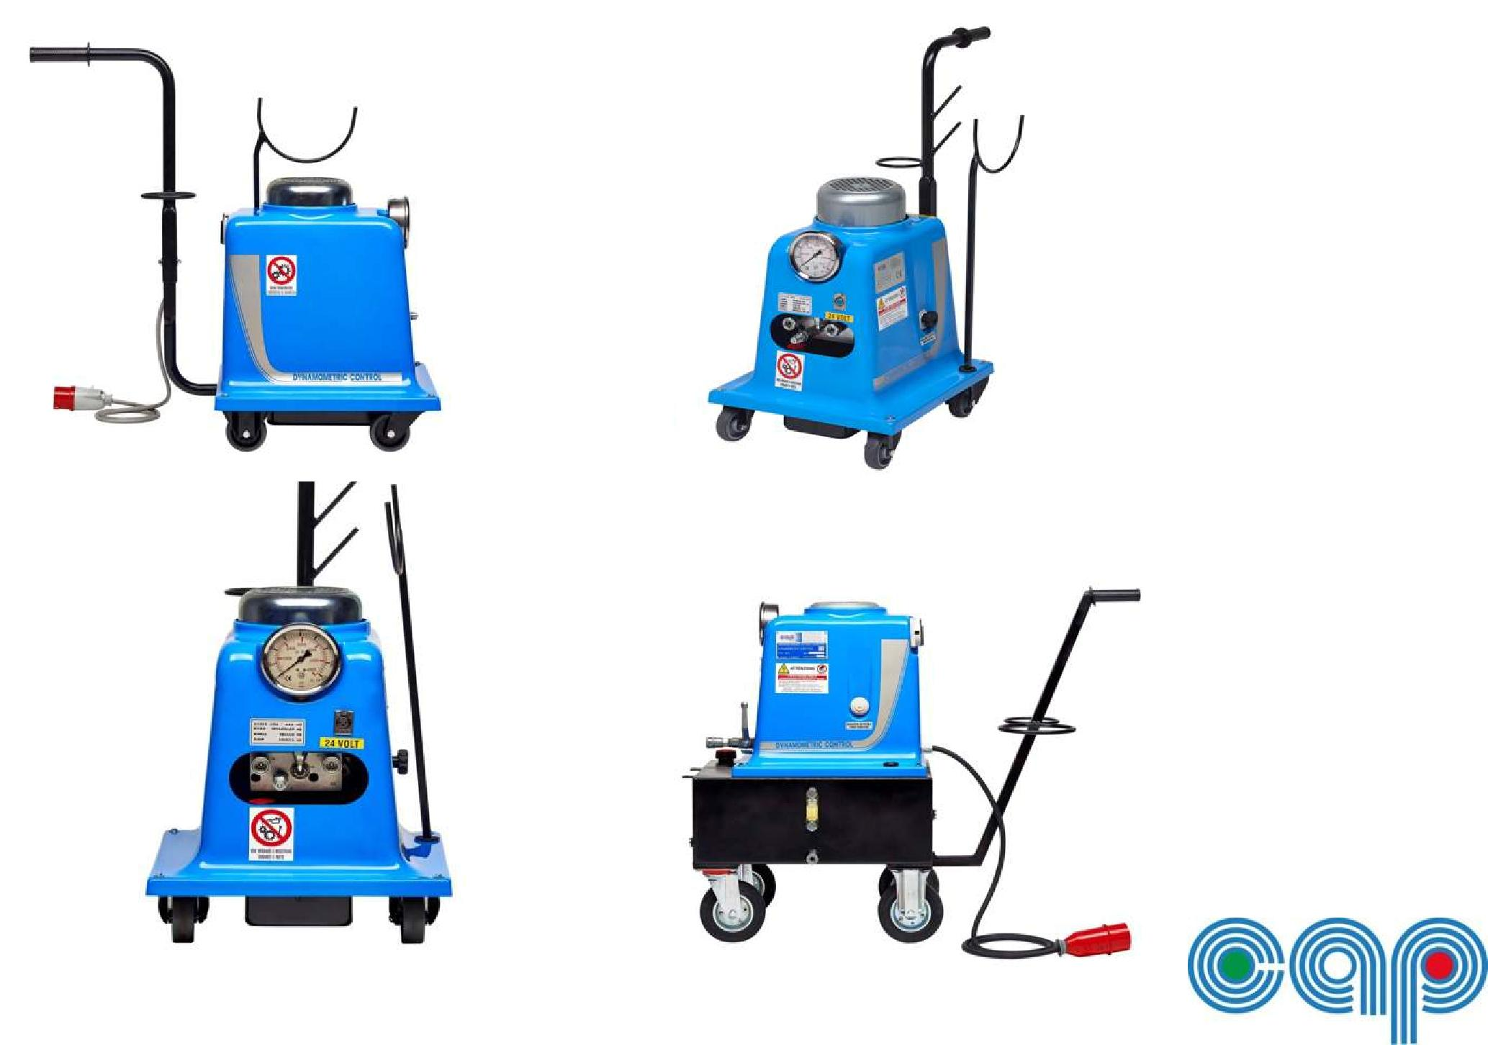
Hydraulic Power Unit Range

- C3.0M6N Power Unit with torque control features and single-phase electric motor
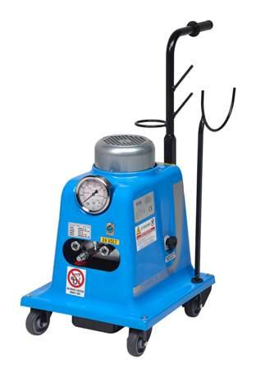
230V – 3HP
- C3.0T6N Power Unit with torque control features and three-phase electric motor

380V – 3HP
- C5.5T6N Power Unit with torque control features and enhanced three-phase electric motor 380V – 5.5HP
- C5.5T45N Power Unit with torque control features and three-phase electric motor 380V – 5.5HP. Comes with 45lt. Oil tank. Recommended for continuous use and/or heavy duty jobs.

- POWER UNIT ACCESSORIES

– Air and Oil Cooler with thermostatic start keeps oil temperature at optimal values.

– Hydraulic hoses, cables and connectors

DYNAMOMETRIC CONTROL
DYNAMOMETRIC CONTROL UNIT | WRENCH | CONTROL UNIT
DCK100C3.0T6N | K100 | C3.0T6N
DCK200C3.0T6N | K200 | C3.0T6N
DCK350C3.0T6N | K350 | C3.0T6N
DCK560C3.0T6N | K560 | C3.0T6N
DCK560C5.5T6N | K560 | C5.5T6N
DCK750C5.5T6N | K750 | C5.5T6N
DCK850C5.5T6N | K850 | C5.5T6N
DCK560C5.5T45N | K560 | C5.5T45N
DCK750C5.5T45N | K750 | C5.5T45N
DCK850C5.5T45N | K850 | C5.5T45N
DCK1600C5.5T45N | K1600 | C5.5T45N

TECHNICAL SPECIFICATIONS CONTROL UNIT
MODEL | INPUT  (V) | *WEIGHT  (kg) | OIL CAPACITY  (liter) | DIMENSION  L x l x h(mm)
C3.0M6N | 230 | 35.60 | 6 | 400x600x700
C3.0T6N | 380 | 35.80 | 6 | 400x600x700
C5.5T6N | 380 | 38.60 | 6 | 400x600x700
C5.5T45N | 380 | 85.50 | 45 | 400x600x810

*Oil included (tank capacity 6N=6L ; 45N=45L)

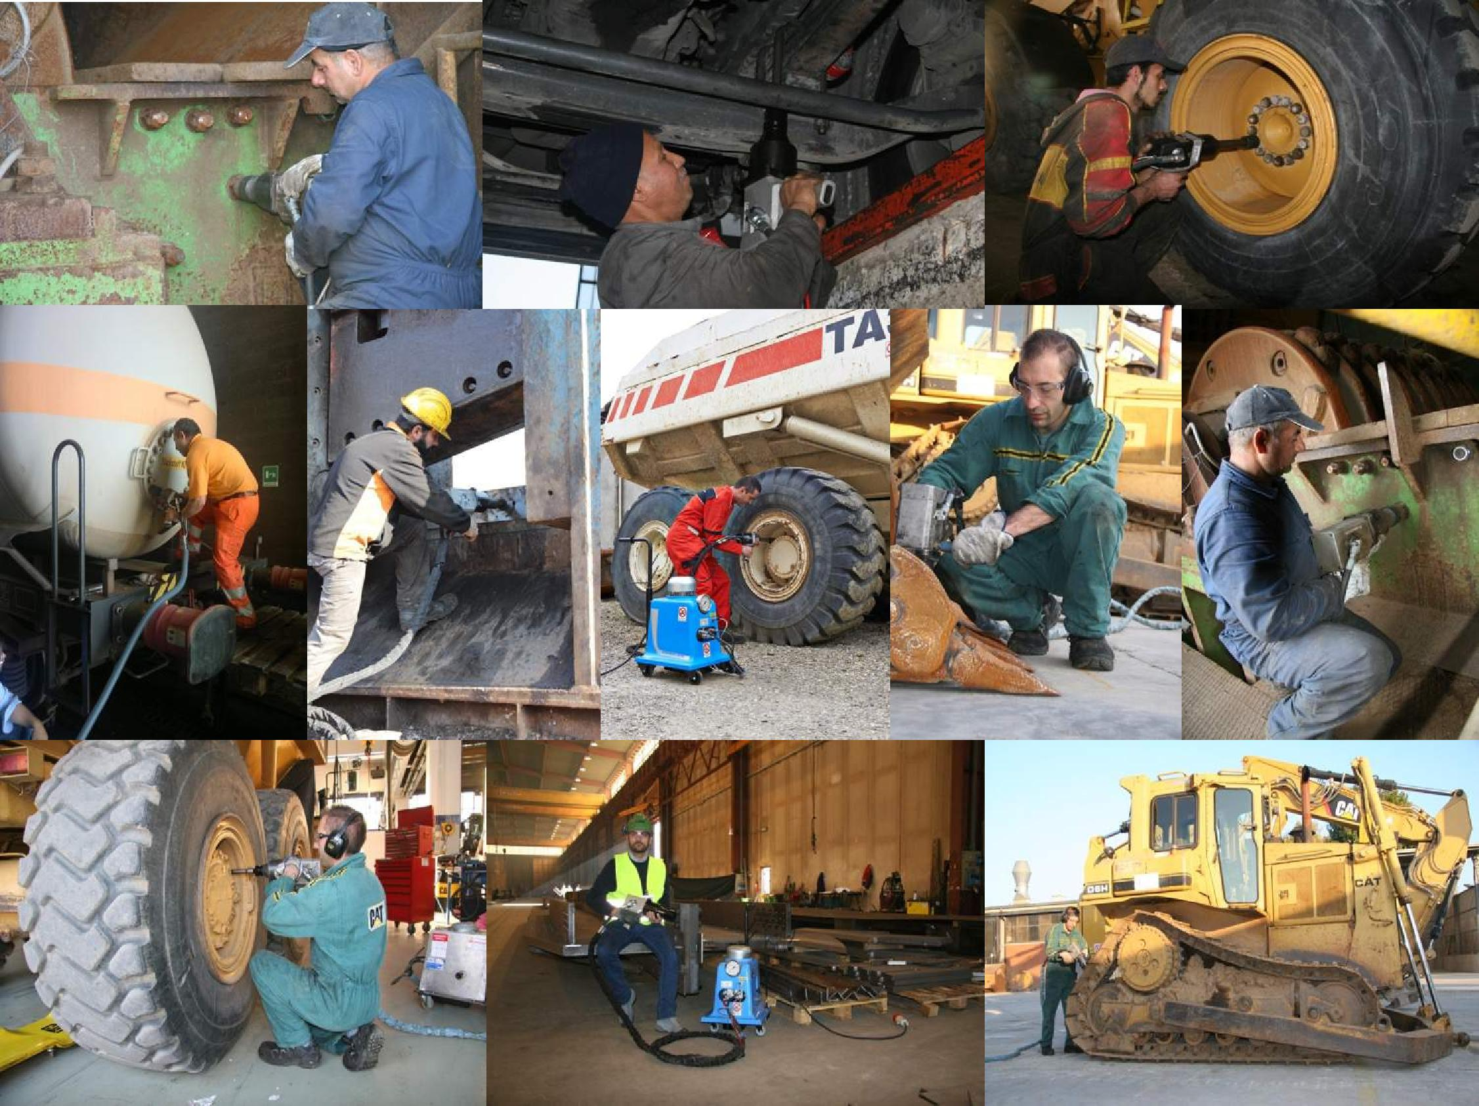
POSITIVE CUSTOMERS EXPERIENCE
